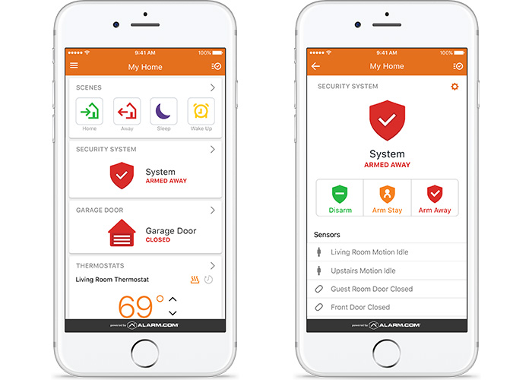

* **Dedicated cellular connection for the security system**
* **Arm and disarm the security system from anywhere through the Mobile App**
* **Create unique user codes to see who has armed or disarmed the system, and when**
* **Provide instant verification of alarms and increased engagement through on-demand views with the Alarm.com Image Sensor**
* **Upgrade compatible 2G or POTS-connected security panels to Alarm.com's award-winning interactive services with the System Enhancement Module**
* **Crash & Smash keeps security systems working, even if the security panel is damaged**
* **Wireless 2-Way Voice to talk to the emergency dispatcher directly through the panel**
* **Using real-time local weather data, the panel will alert customers to dangerous weather conditions**